**DB LAB 08**

**MOHAMMAD BASIL ALI KHAN**

**20K-0477**

CREATE TABLE PageRevision(

name VARCHAR(12),

adate DATE,

author VARCHAR(12),

text VARCHAR(50));



Question#01:

CREATE TABLE Page(

name VARCHAR(12),

last_author VARCHAR(12),

text VARCHAR(50));

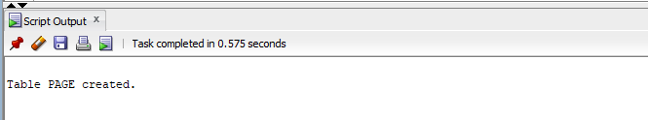

Question#02:

CREATE OR REPLACE TRIGGER page_revision_trigger

BEFORE UPDATE

ON PageRevision

FOR EACH ROW

ENABLE

BEGIN

INSERT INTO Page

VALUES (:OLD.name, :Old.author, :OLD.text);

END;

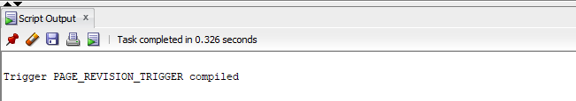

SELECT *

FROM PageRevision;

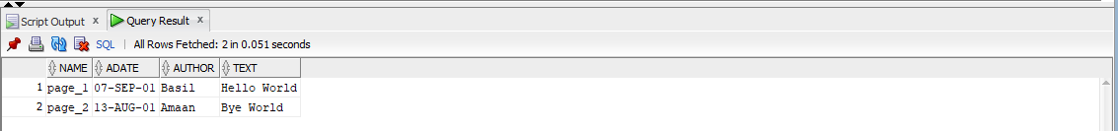

UPDATE PageRevision

SET author = 'Ali'

WHERE name = 'page_2';

SELECT *

FROM PageRevision;

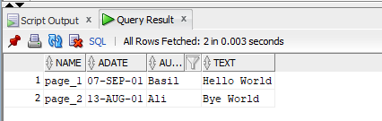

SELECT *

FROM Page;

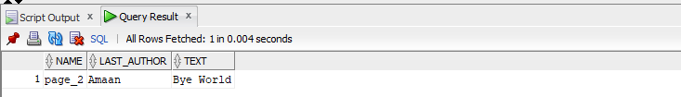

Question#03:

CREATE TABLE DeleteLog (

name VARCHAR(20),

adate DATE);

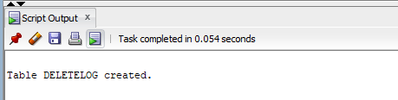

CREATE OR REPLACE TRIGGER delete_log_trigger

BEFORE DELETE

ON PageRevision

FOR EACH ROW

ENABLE

BEGIN

INSERT INTO DeleteLog

VALUES (:OLD.name, :OLD.adate);

END;

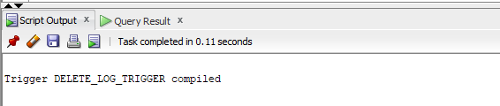

DELETE FROM PageRevision

WHERE name = 'page_1';



SELECT *

FROM PageRevision;

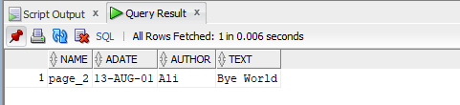

SELECT *

FROM DeleteLog;

